Project Design Phase-II
Data Flow Diagram & User Stories
Date | 2 July 2026
Team ID
Project Name | Rising Waters
Maximum Marks | 4 Marks

Data Flow Diagrams:
A Data Flow Diagram (DFD) is a traditional visual representation of the information flows within a system. A neat and clear DFD can depict the right amount of the system requirement graphically. It shows how data enters and leaves the system, what changes the information, and where data is stored.
Example: (Simplified)
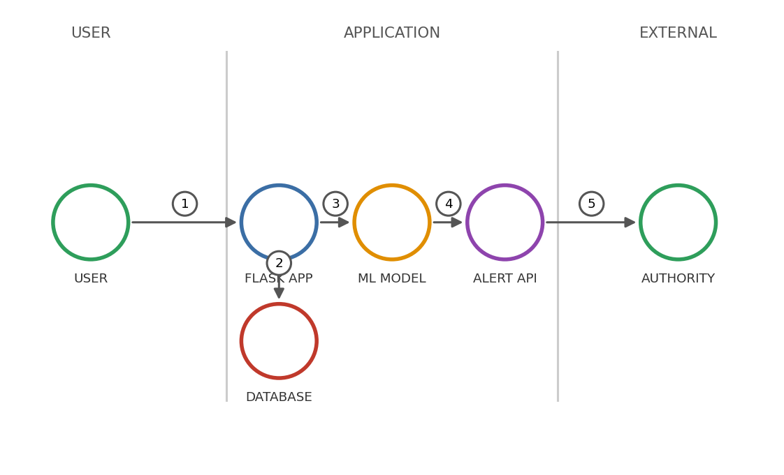  1. Field officer opens the app and logs in.  2. Rainfall and cloud-visibility readings are entered and sent to the Flask app.  3. Flask app stores the raw reading in the weather database.  4. Preprocessed features are passed to the trained ML model for prediction.  5. If risk is High/Medium, the alert API notifies the relevant authority. | 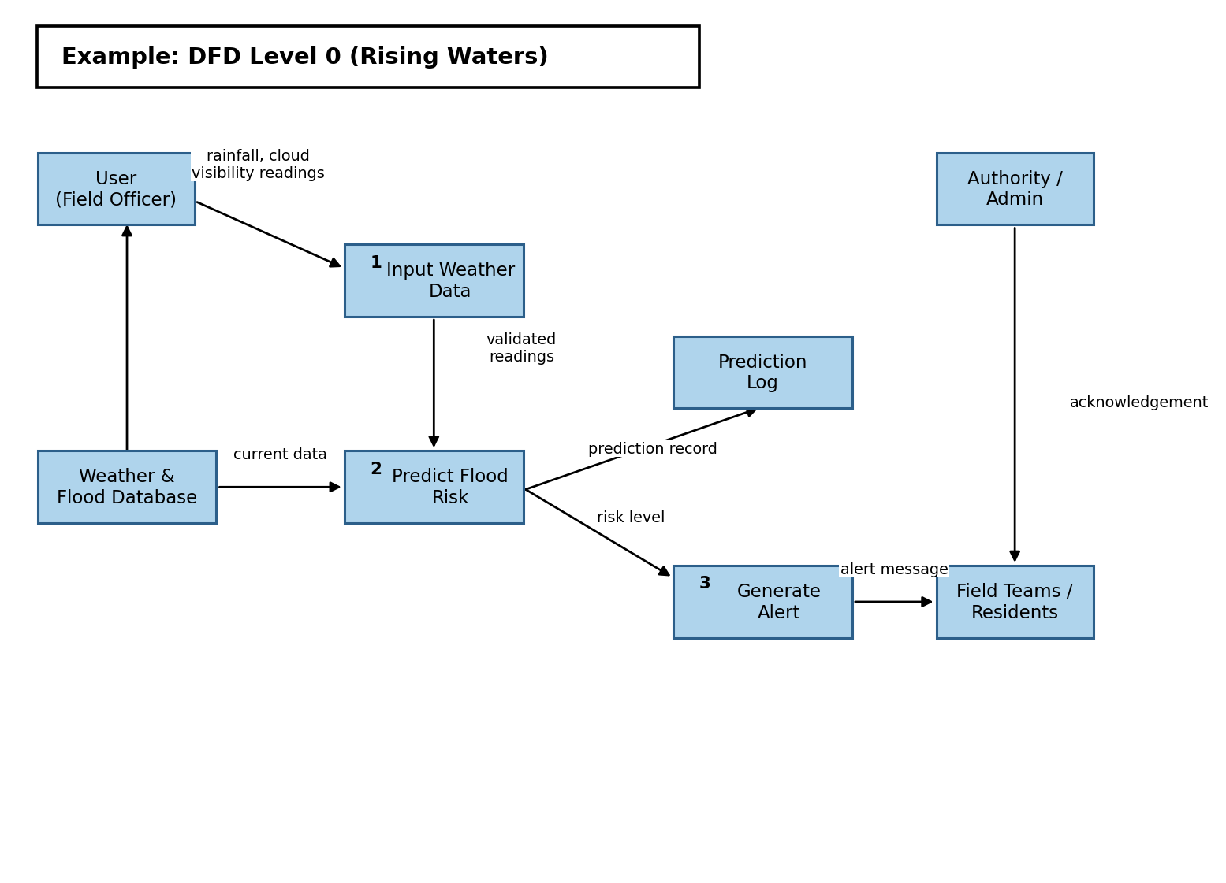

User Stories
Use the below template to list all the user stories for the product.
User Type | Functional Requirement (Epic) | User Story Number | User Story / Task | Acceptance criteria | Priority | Release
Field Officer  (Mobile user) | Registration | USN-1 | As a field officer, I can register for the application by entering my name, email, region and password. | I can access my account / dashboard | High | Sprint-1
 |  | USN-2 | As a field officer, I will receive a confirmation email once I have registered for the application. | I can receive confirmation email & click confirm | High | Sprint-1
 |  | USN-3 | As a field officer, I can register for the application through Gmail. | I can register & access the dashboard with Gmail login | Medium | Sprint-1
 | Login | USN-4 | As a field officer, I can log into the application by entering email & password. | I can log in and reach my region's dashboard | High | Sprint-1
 | Weather Data Entry | USN-5 | As a field officer, I can enter current rainfall and cloud visibility readings for my region. | Reading is saved and timestamped against my region | High | Sprint-1
 |  | USN-6 | As a field officer, I can upload a CSV of readings for multiple stations at once. | All valid rows are imported; invalid rows are flagged | Medium | Sprint-2
Disaster  Coordinator  (Web user) | Dashboard | USN-7 | As a coordinator, I can view flood-risk classification for all monitored regions on one screen. | Dashboard lists each region with a High/Medium/Low risk tag | High | Sprint-1
 |  | USN-8 | As a coordinator, I can compare a region's current readings against its historical flood trend. | A trend chart is shown for the selected region | Medium | Sprint-2
 | Alerts | USN-9 | As a coordinator, I receive an automatic email/SMS alert when a region is classified as high risk. | Alert is sent within 2 minutes of a high-risk prediction | High | Sprint-1
Government  Analyst | Model Validation | USN-10 | As an analyst, I can run the model against historical flood records and view its accuracy. | Accuracy report (e.g. 96.55%) is displayed with a confusion matrix | Medium | Sprint-2
Administrator | User Management | USN-11 | As an administrator, I can approve or reject new field-officer and coordinator registrations. | Only approved accounts can log in | Medium | Sprint-2
 | Model Management | USN-12 | As an administrator, I can retrain the model with newly collected data and publish the best-performing version. | New model is versioned and live predictions use it after publishing | Low | Sprint-3

